GROUP ASSIGNMENT
GROUP MEMBERS REG NO

1. LINO NGOR MAJOK MANGOR 2405000678
2. YVES BAHATI 2305000895
3. EDGAR GAPFIZI BAHATI 25011938
4. ELYSÉE NIYIBIZI 2305000921
5. DANIEL NIZEYIMANA 2401001868

Q1.

Creating a pandas data frame
Viewing the dataset,
summarizing contents, identifying invalid data,
converting data type columns,
and treating all missing values

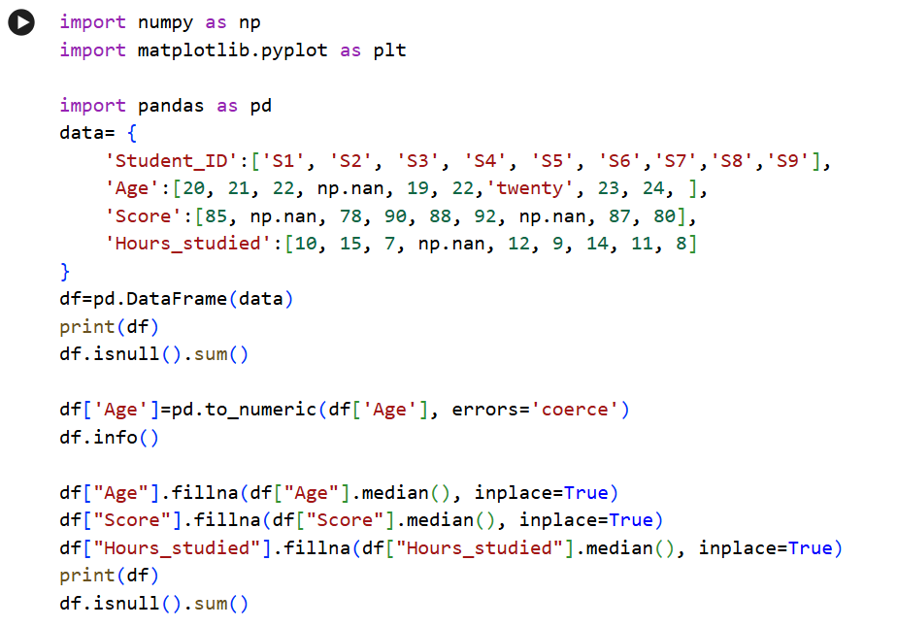
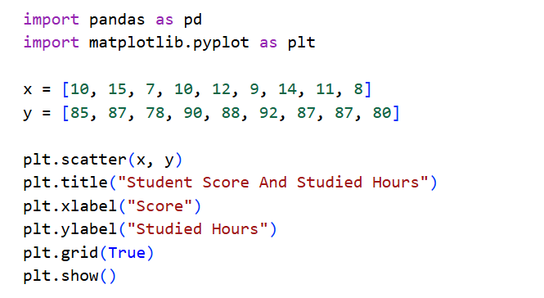


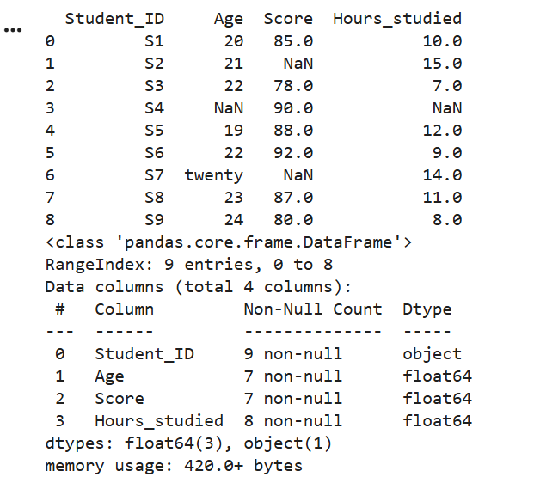

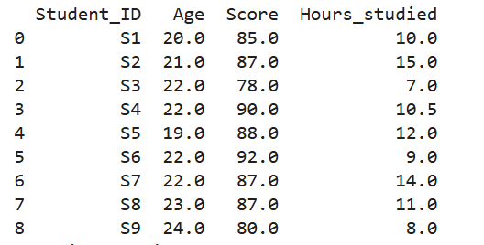

Plotting a scatter plot 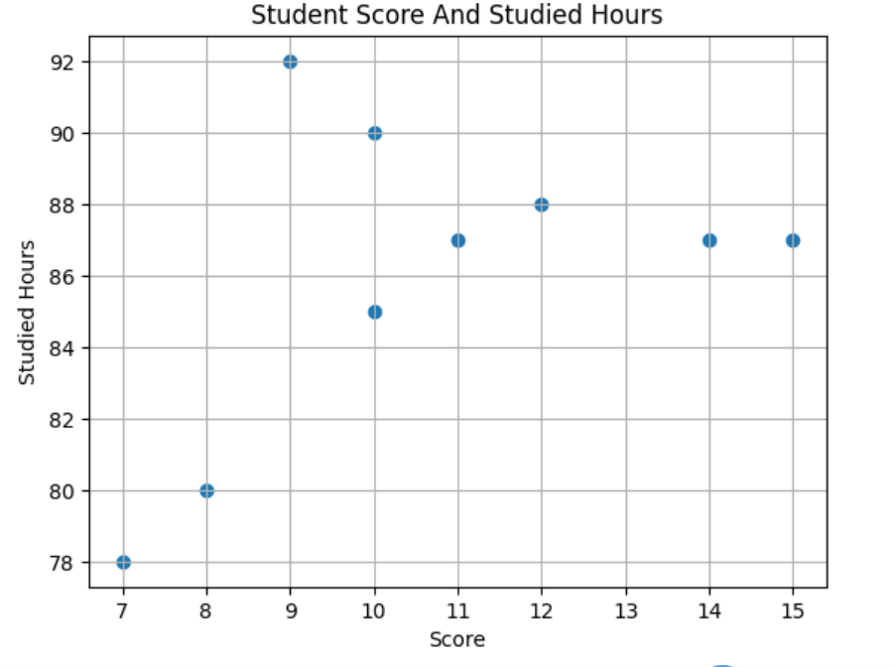

Q2.

A.

A cleaner Dataset with fewer missing values is more reliable for analysis and model training. Enhanced model performance: Properly handling missing values helps models perform better by training on complete data, leading to more accurate predictions.

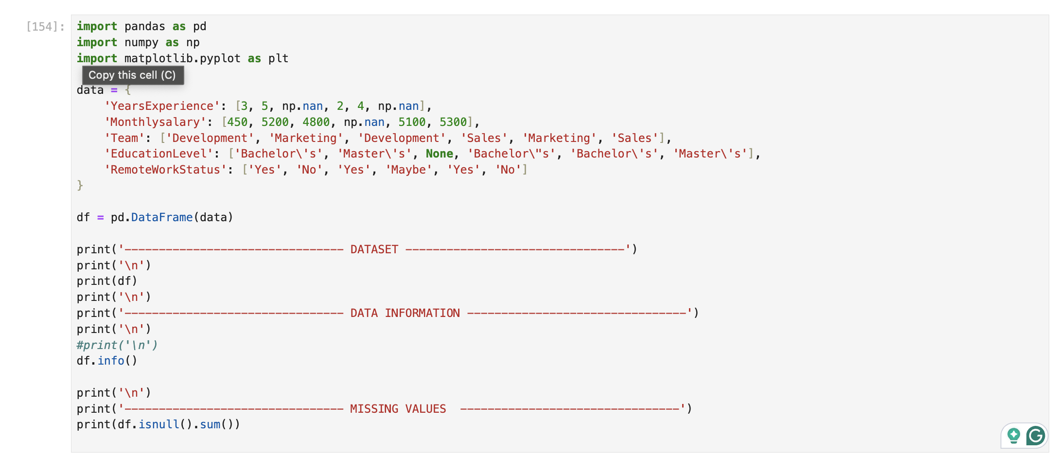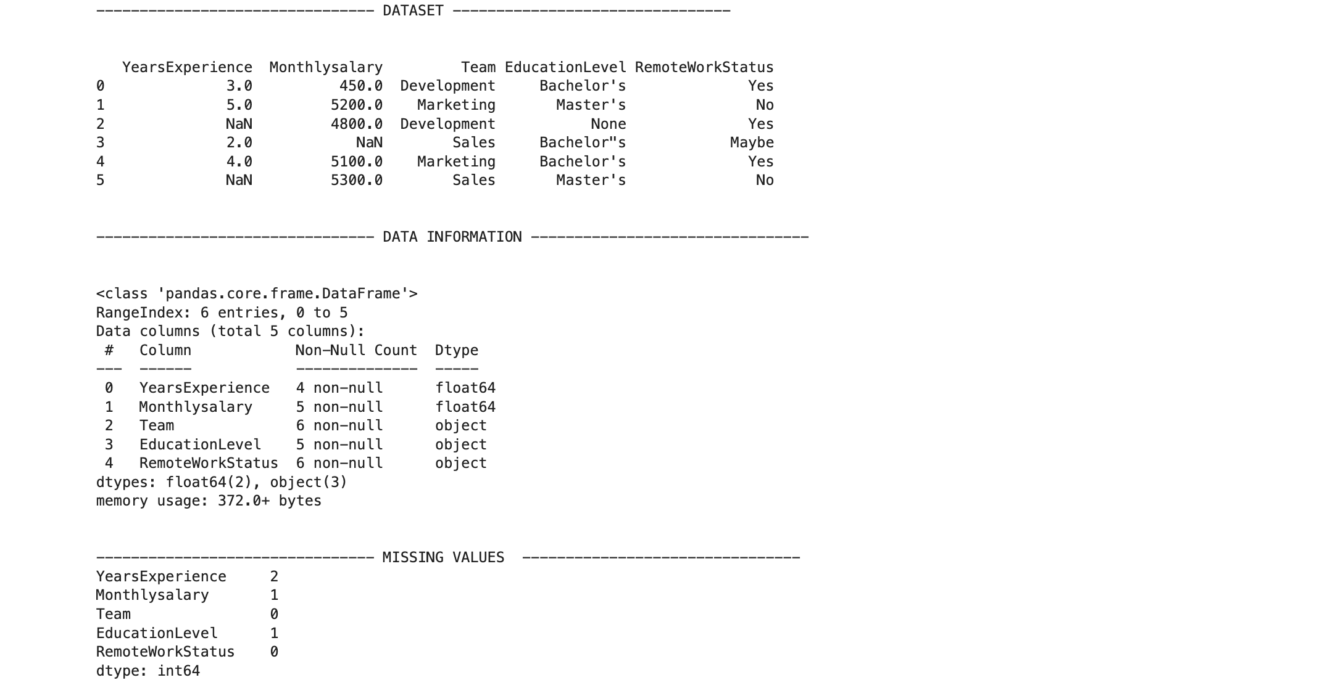

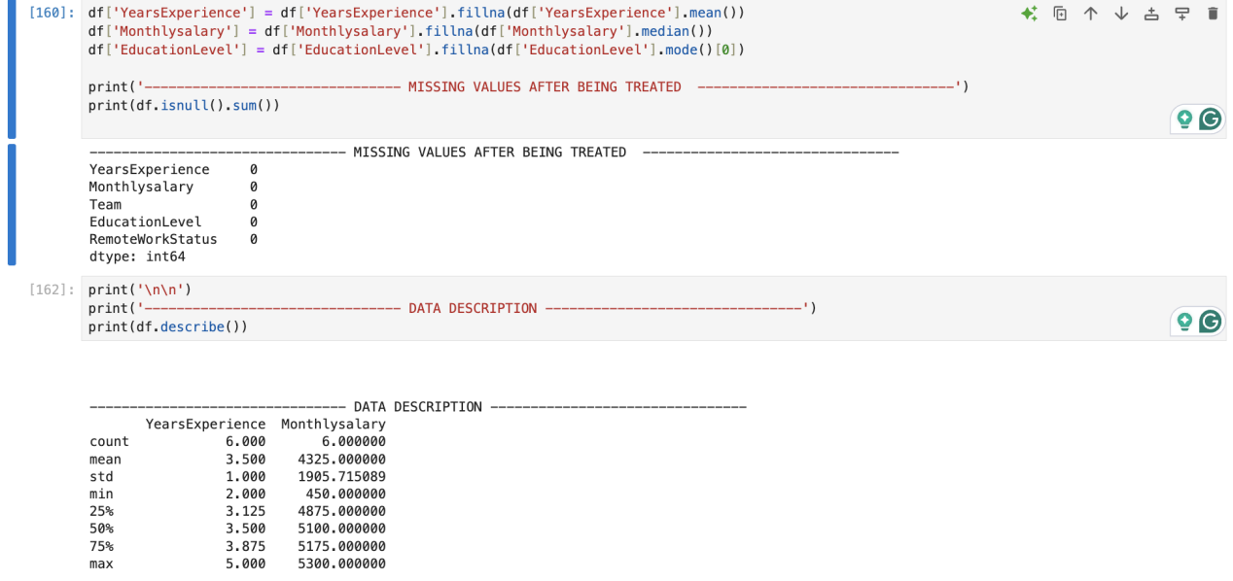

- CALCULATING MEDIAN FOR MONTHLY SALARY
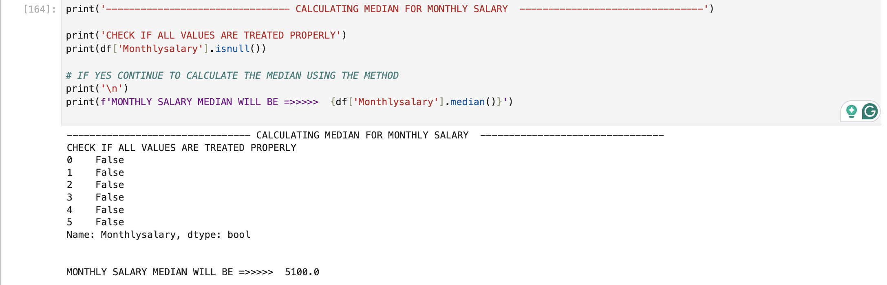

C.

- GENERATING A NEW COLUMN FOR PERFORMANCE SCORE

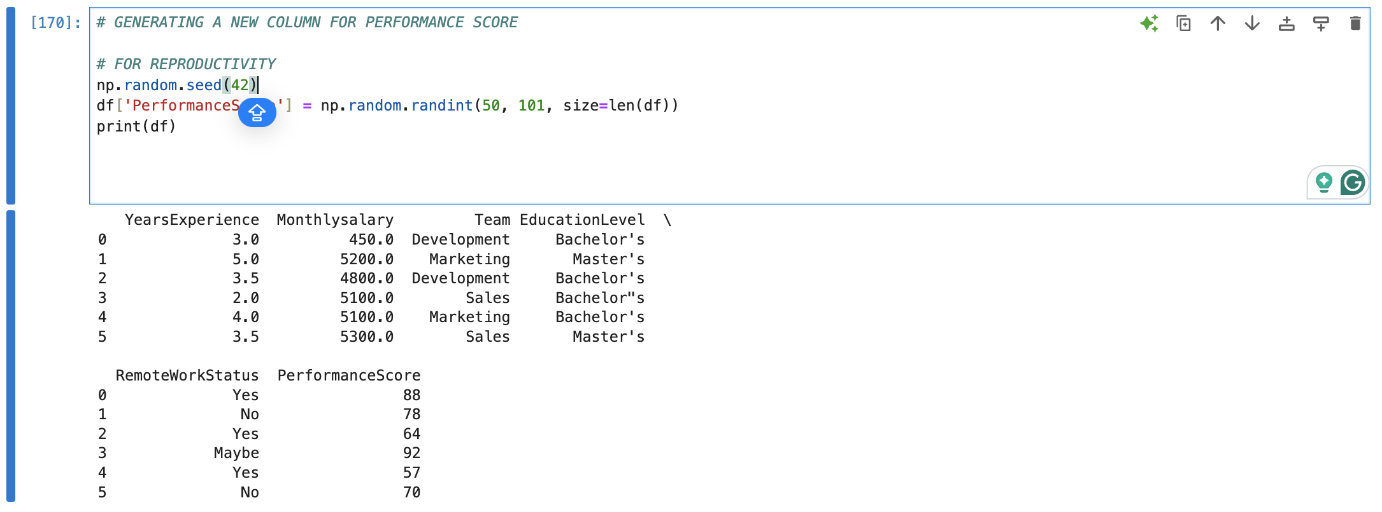

- YEARS OF EXPERIENCE VERSUS PERFORMANCE SCORE

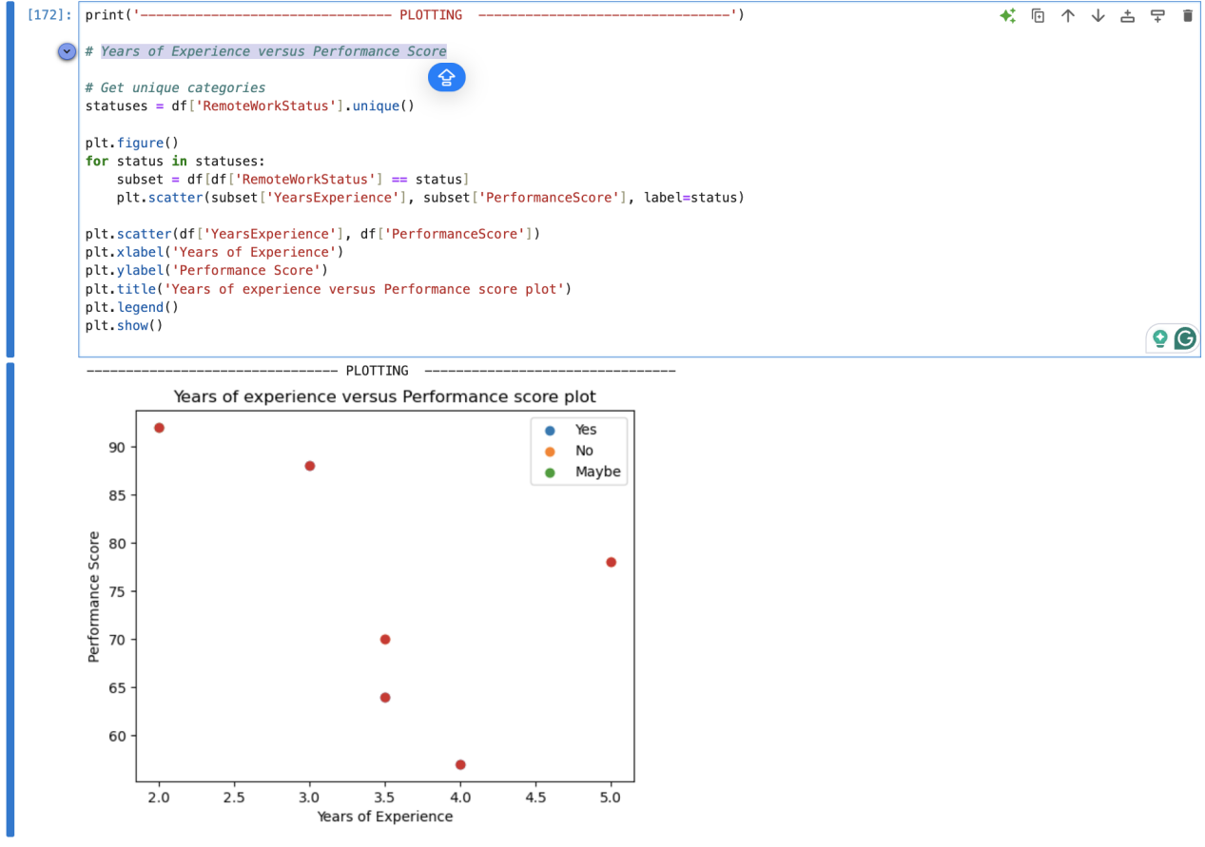

Question 3.
A.
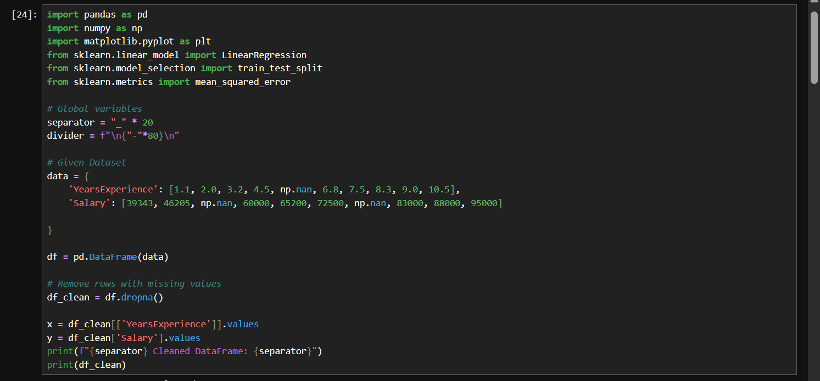
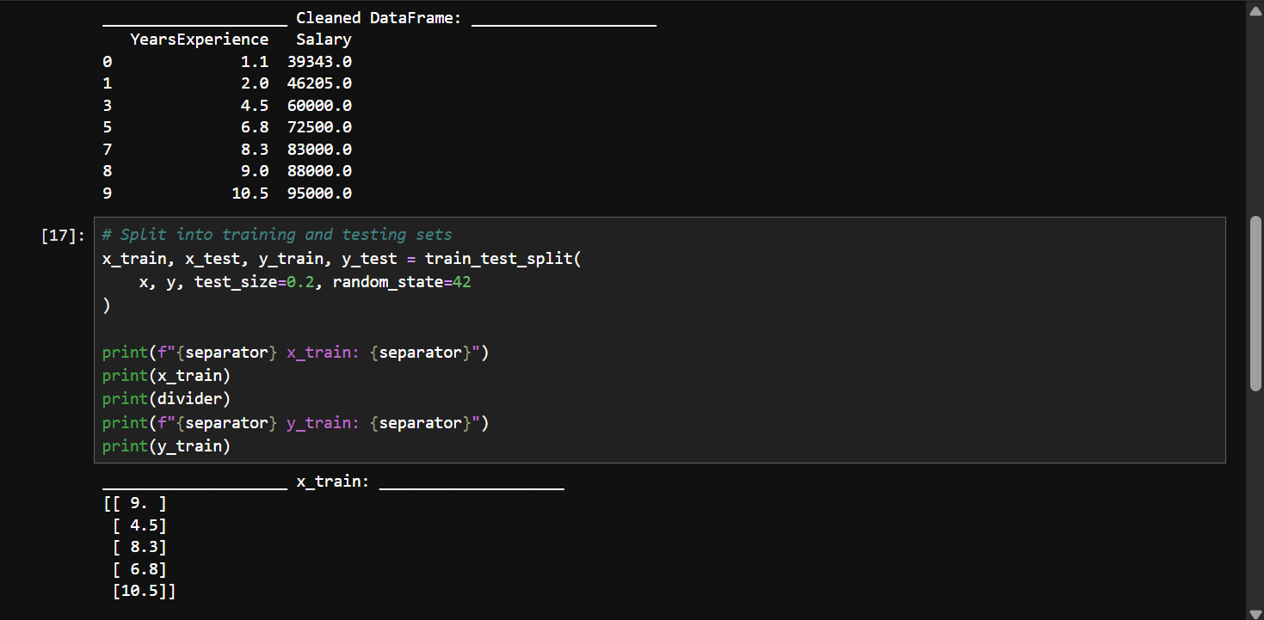
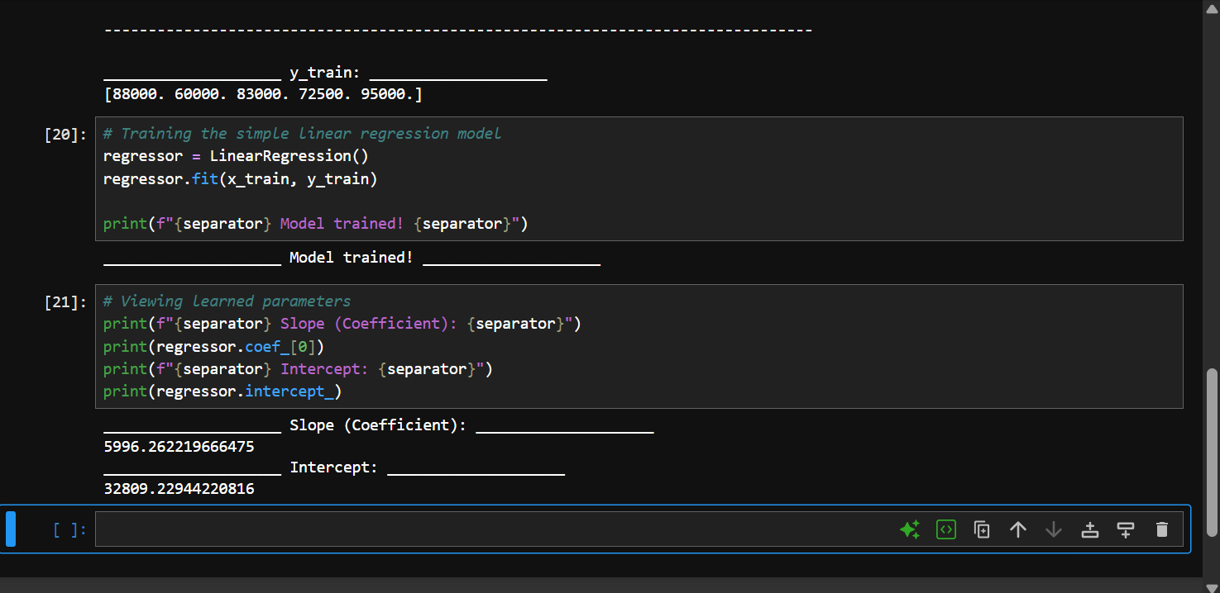

B.
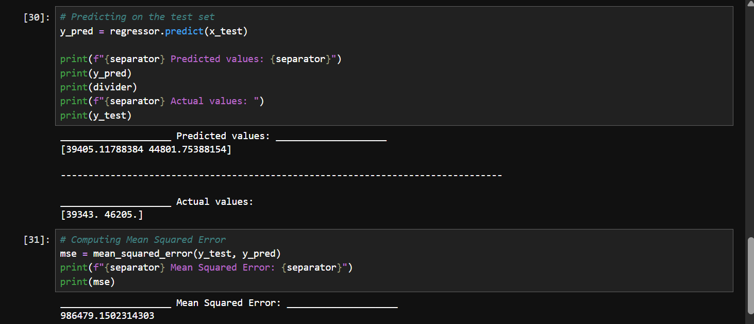
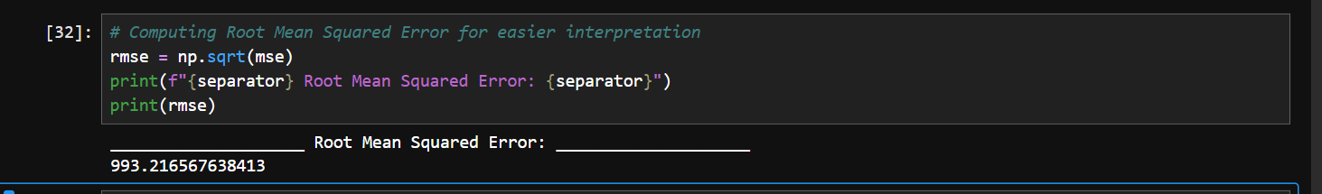

C.
